**Project Design Phase Solution Architecture**

|  |  |
| --- | --- |
| Date | 21 February 2025 |
| Team ID | SWTID1744456946 |
| Project Name | MediBoard |
| Maximum Marks | 4 Marks |

**Solution Architecture:**

Solution architecture is a complex process – with many sub-processes – that bridges the gap between business problems and technology solutions. Its goals are to:

* Find the best tech solution to solve existing business problems.
* Describe the structure, characteristics, behaviour, and other aspects of the software to project stakeholders.
* Define features, development phases, and solution requirements.
* Provide specifications according to which the solution is defined, managed, and delivered.

**Example - Solution Architecture Diagram:**

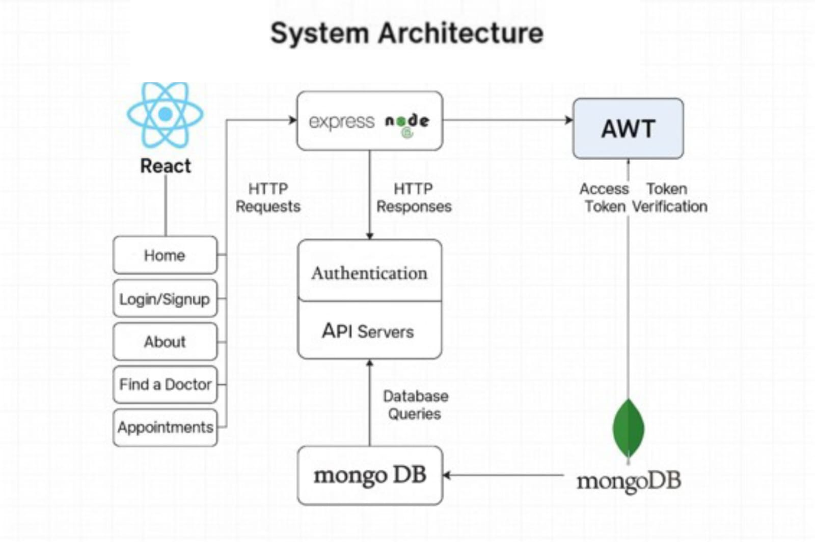

**Architecture Breakdown:**

# Client Side (React.js)

* + The user (doctor or patient) interacts via the browser.
  + Pages like Home, About, Find a Doctor, Appointment Booking, Dashboards.
  + Uses Axios/Fetch to communicate with the backend via RESTful APIs.
  + Stores JWT tokens.

# API Gateway (Express + Node.js)

* + **Routes:**
    - /api/authentication – login, signup for both roles.
    - /api/doctors – list, filter, profile view.
    - /api/appointments – create, update, cancel, fetch.
    - /api/patients – patient data, dashboard info.

# Middleware:

* + - Auth middleware verifies JWTs before granting access.
    - Role-based access control (Doctor/Patient).
    - Input validation & error handling.

# MongoDB Database

* + Collections:
    - **Users** (doctors & patients, roles, hashed passwords)
    - **Doctors** (name, department, schedule, ratings)
    - **Appointments** (time, doctorId, patientId, status)
  + Relations via ObjectIds – efficient querying and filtering.

# Authentication Layer (JWT)

* + On login/signup, JWT is issued and returned to client.
  + Frontend stores token and includes it in the Authorization header.
  + Backend verifies token for protected routes.